POE316G
- Product Description：
The POE316G is a standard POE switch that provides 16*10/100M adaptive RJ45 ports 、2*10/100/1000M uplink adaptive RJ45 port and 1*1000M uplink SFP slot port . Ports 1~16 features POE power supply capability and can be used as Power over Ethernet devices. The power supply port can automatically detect and recognize the powered device that complies with the IEEE 802.3af/at standard and supply power through the network cable.Supports two modes: normal switch mode/250M ultra-long transmission. POE316G makes it easier for you to deploy wireless access point (AP) and IP terminal network devices using POE technology.

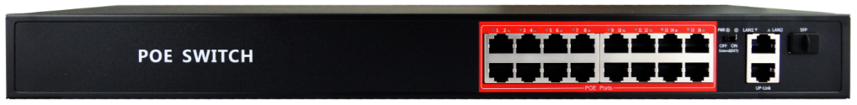

- Product characteristics:
- Supporting 802.3 Ethernet, 802.u Faster Ethernet；
- Supports POE IEEE 802.3af/at compliant Powered Device (PD)
- Modes: Normal switch mode/Extended mode(Port1-16:250Metres ultra-long transmission)
- Ports 1~16 features POE power supply capability and can be used as Power over Ethernet devices；2*10/100/1000Base-T Uplink and 1*1000Base-X SFP.
- Auto MDI/MDIX crossover for all ports
- Support full duplex based on IEEE802.3x and half duplex based on Backpressure
- Support non-blocking wire speed forwarding
- MAC address auto-learning & auto-aging
- Steel case，the total POE power budget of 240 W
- Just Plug and Play

- Technical specification and parameter：
Interface |  | 16*10/100M POE ports (Data /Power)  2*10/100/1000M uplink RJ45 ports (Data)  1*1000M uplink SFP slot port (Data)
Basic function |  | Follow IEEE 802.3 Ethernet and IEEE802.3u Fast Ethernet Protocol  Supports POE IEEE 802. 3af/at compliant Powered Device (PD)  Store-and-forward switching scheme  Support IEEE802.3X full duplex and Backpressure half duplex  MAC address auto-learning & auto-aging
Standards |  | IEEE802.3 10BASE-T;  IEEE802.3i 10Base-T;  IEEE802.3u 100Base-TX;  IEEE802.3ab 1000Base-T;  IEEE802.3z 1000Base-X;  IEEE802.3x  IEEE802.3af/at
Mode |  | Normal switch mode/Extend mode
Data Transfer Rate |  | Ethernet : 10Mbps(Half-duplex);20Mbps(Full-duplex)  Fast Ethernet :100Mbps(Half-duplex);200Mbps(Full-duplex)  Gigabit Ethernet:2000Mbps(Full-duplex)
Performance | Store&Forwarding | Yes
Performance | Switching Capacity | 9.2G
Performance | MAC Address Table Size | 2K
Performance | Jumbo Frame | 2048 byte
Environmental |  | Operation Temperature：0℃～40℃  Storage Temperature：-40℃～70℃
Operation Humidity：10%～90% RH Non-condensing
Storage Humidity：5%～90% RH Non-condensing
Power Input POE Standards |  | Single port maximum power 30W, whole switch maximum power 240W  Supporting over-current, over-voltage and short-circuit protection  Supporting Soft Start of High Power PD  Support sequential boot-up  Power Supply Pin:12+/36-
 |  | AC 110~240V 50/60HZ
Cabling type |  | 1000BASE-T : Cat5e or better UTP(≤100m)  100Base-TX: Cat 5e or better UTP/STP(≤100m)  10Base-TX: Cat 5e or better UTP/STP(≤250m)
Physical dimensions |  | 440mm*180mm*43mm(W x D x H)

